Assignment 4_1

1.Histogram for all variables in a dataset mtcars. Write a program to create histograms for all columns.

library(ggplot2)

library(tidyr)

mtcars %>% gather() %>% ggplot(aes(value)) + facet_wrap(~ key, scales = "free") + geom_histogram()

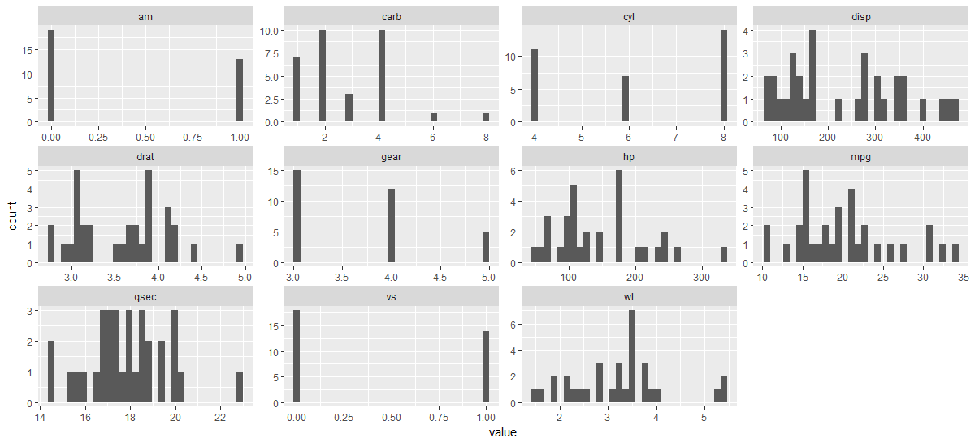

2. Check the probability distribution of all variables in mtcars

3. Write a program to create box plot for all variables.

boxplot(mtcars)

